First and last names of authors (Times New Roman 11, Bold)

Affiliation (Times New Roman 11, Bold, курсив)

TITLE OF PAPER (Times New Roman 12, Bold)

Summary (Times New Roman 10, Bold)

Text of up to ten pages (with pictures) must be submitted in a form ready for publication: typed in Microsoft Word version 6 or later; Times New Roman 12, normal, single spacing between lines. All fields are 1 cm. Paragraph indent is 1 cm. Word hyphenation is not allowed. Pages are not numbered.
All figures of the appropriate size in .jpg or .tif format with a compression and a resolution of 300 dpi must also be provided by SEPARATE FILES.

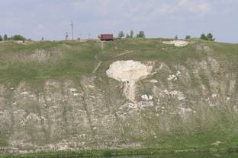
Fig. 1. Figure caption (Times New Roman 10)

Please, use comma as decimal separator in numbers. Also to prevent unwanted gaps in the text use the “linked space” function (simultaneously pressing Shift-Ctrl-space).
The list of references is made in order of citation in the article.
The article should be submitted to the organizing committee in electronic form.
The editorial board, if necessary, can independently conduct technical and literary editing of materials.

References (Times New Roman 12, Bold)
- Nonveiller, E. Shear strength of bedded and joined rock of landslides with noncircular surfaces with special reference to Vajont slides // Proceedings of Geotechnical Conference. – Norwegian Geotechnical Institute, 1967. – pp. 289-294.

